**Sprint-1**

|  |  |
| --- | --- |
| Date | 2 November 2022 |
| Team ID | PNT2022TMID24844 |
| Project Name | Project: Signs with Smart Connectivity for Better Road Safety |
| Marks | 20 Marks |

**US-1:** Create the IBM Cloud services which are being used in this project.

**US-2:** Configure the IBM Cloud service which are being used in completing this project.

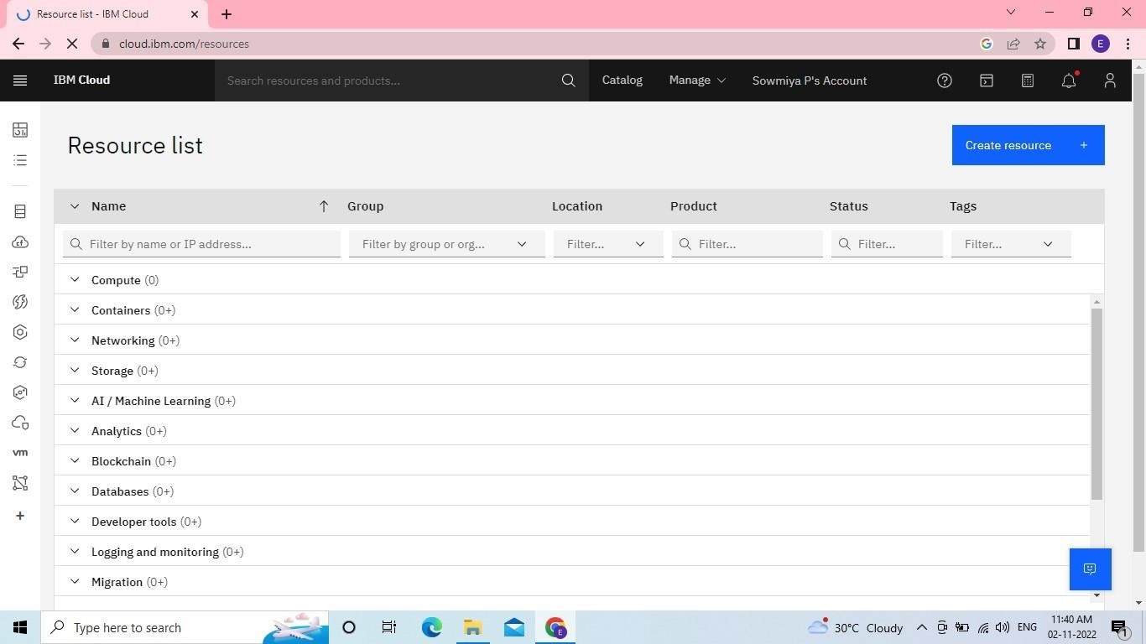

**US-3:** IBM Watson IoT Platform acts as the mediator to connect the web application to IoT devices, so create the IBM Watson IoT platform.

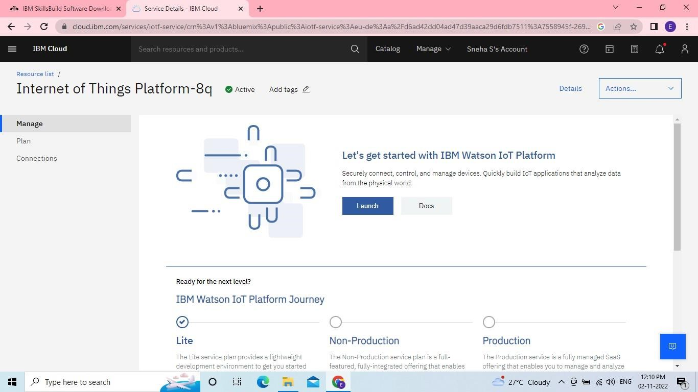

**US-4:** In order to connect the IoT device to the IBM Cloud, create a device in IBm Watson IoT platform and get device credentials.

